Real Estate

Group member: Roll numbers:
- Sohaib Hassan 2025CS266
- Shaihzaib Ahmed 2025CS252
- Muhammad saim 2025CS
- Ameer muawiya 2025CS

Course: 2025 computer science
Course instructor name: Ramsha khalid
Submission date: 8 -1- 2026

Executive summary:
Our company name is rocket real estate company .first what is real estate .so basically, real estate is a business in which one sells an owns property. It is a very interesting business and also very profitable. In our country Pakistan real estate business is facing many problem because everyone is now cheating. We have created a business in which we are confident that nothing unjust will happy to our customers .our customers can buy and sell any property through us without any hesitation. We are dealing with both residential and commercial plots. Our services include that we can hep you buy and sell any property with full confident in addition to that we can also help in renting any apartment or property, we will also give guidance towards starting a real estate business several courses will be offered to you . so in short we will deal with everything involving the word property.now question arises why will you choose us .first we have experienced agent. Seriously very experienced agents. Than secondly we have verified listings,transparent pricing, market expertise. So you will not regret choosing us. As I have previously said that we will deal with any thing involving property, we will deal with residential homes and apartments , commercial plots, land,luxury properties,investment properties etc. So that’s our summary.

Project Objectives
The main objective of this project is to design and develop a real estate website that showcases property listings in a clear, and user-friendly manner. The website is intended to simulate a real-world real estate platform where users can view available properties, learn about the agency, and contact the seller or agent easily.Specific objectives of the project are:
- To design a structured website using HTML5 and CSS .
- To present real estate properties such as houses, apartments, and commercial plots with images, prices, locations, and basic features.
- To improve user experience by organizing content into clear sections such as Home, About, Properties, Gallery, and Contact.
- To apply modern layout techniques such as Flex-box or CSS Grid for proper alignment.
- To practice professional documentation, data organization (Excel), presentation (PowerPoint), and version control using GitHub.

Project Scope
The scope of this project is limited to the front-end development and presentation of a real estate website. The website focuses on displaying sample property listings and does not includes back-end functionality.The scope includes:
- A static real estate website developed using HTML and external CSS.
- Pages such as:
- Home: Introduction to the real estate business and featured properties.
- About: Information about the agency and its mission.
- Properties/Services: Listings of properties with prices, sizes, and locations.
- Gallery: Images of properties with captions.
- Contact: Contact form and basic contact details.
- Use of sample data for property prices, locations, and sizes, which will also be documented in Excel and PowerPoint.
- layout suitable for desktop and mobile viewing.
- Publishing the project code on GitHub and linking it with other deliverable.
The project does not include:
- Backend development (databases, user login, payment systems).
- Real-time property updates or online transactions.

Site structure :
For the purpose of our project we have created a beautiful website all according to the rubrics. So our website consist of four pages as follows:
- Home:
This is first page which open when you click on our prestigious website. In the homepage first on the top there is a slogan of our so called business. This slogan is made on canvas and we have supposed that our business name is stack stone cores so it is written on that slogan in a very beautiful manner. Below that slogan there are four option options which corresponds to our four pages of website. These four pages are home services contact us and about. Below these options there is again a slogan which is your vision our expertise which is again to impress our customers below that there are several details about our so called company everything is written there and last but not the least below that there are photos of our projects and two of the houses were more beautiful and expensive than other so we attached the videos of them also this is all about the home page
- About:
So the next page is about. In this page first again on the top there is a slogan, same slogan.then there is a note which says a name of comfort and luxury again to impress our customers than we have several details about us all the details are divided into four columns. In the first column we explain our company in second we explain all our services in the third we explain why choose us and in last we explain the property type we deal with
- Services:
Third page is about services in this page we show our customers our services . page start again with the slogan and then we have a note on our website which says building trust delivering values. Below that all our services are written and below that we have shown our 4 properties which are under sale and also their prices

- Contact us:
This Is the last page in which we have written all our contacts. The page starts with our slogan below that there is a note again which says turning properties into possibilities. And below that all the details of our contact are shows office address phone and email address all are there.

Site navigation:
The navigation in our website is easy . first on the homepage there are four options below the slogan. These options correspond to four pages we can navigate to new page by just clicking at any of these option.furthermore there are other navigation method for example in the second page we have given a navigation option at the end which directs you to contact page.

Design choices:
In order to explain design choices we have divided this section into three sub section:
Font:
We have created our whole website using the font times new roman it has several size in different places for example in notes the font size is greater and in paragraphs it is small we have chosen this font because it is user friendly and it is beautiful
Colours:
We have used three different colors in our website making it simple. First the background colour is white and we have used the colour brown for our main main heading tabs and headings h1. we have used colour blue for our sub heading tabs

Layout decisions:
We have used simple layout very simple because in order to make complex layout we demand higher knowledge which we still lac so a simple layout. Each website page follows the same layout on the top there is a slogan than there is an attractive note than there are heading and then sub heading and under subheading there is text written in centre in short font size related to that sub heading.

Assets used:
so basically we have used two assets first asset is canvas and than there are images. Both of them are described below:
Canva: so we have used canva to build our business slogan. Every business has a slogan and to some people whether a business is match to their business this is seen by comparing slogans slogan also have many other function they make our website beautiful. We have used canvas because it is easy to use and one of our project members know how to use it. It helped us a lot

Images: So our business one thing is required very much that are images because our project deals with properties , people will not perform any thing related to properties whether it is to sale hem or buy the without seeing the image of the properties so using images was very essential for us we have copied images from google.

Videos: We have used 2 videos to show two properties.these videos shows these houses very briefly

EXCEL FIGURES:
We have used excel in order to show the properties which are for sold and their price in addition to their prices and their status that whether they are for sale or not. Folllowing is a detail excel worksheet

Property ID | Property Type | Location | Price (USD) | Status
1 | House | City Center | 120000 | For Sale
2 | Apartment | Downtown | 90000 | For Sale
3 | Commercial | Business Bay | 250000 | For Rent
4 | House | Suburbs | 80000 | For Sale
5 | Apartment | City Center | 100000 | For Rent
6 | Commercial | Downtown | 300000 | For Sale

Property data overview:
Now we will exlpain things with our slides here is a slide which show our property overview
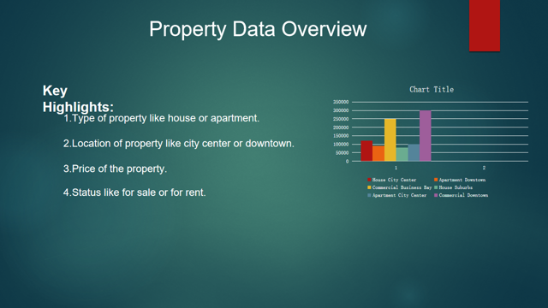

Live site url:
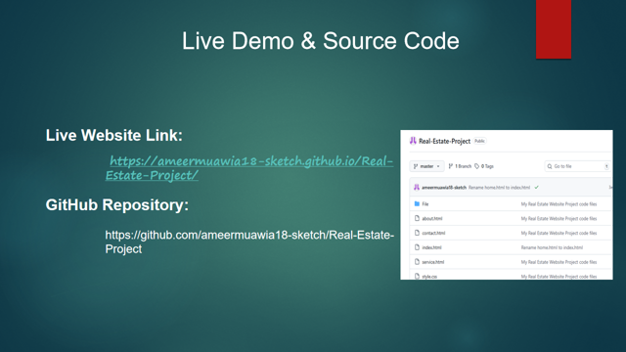

Reflection:
